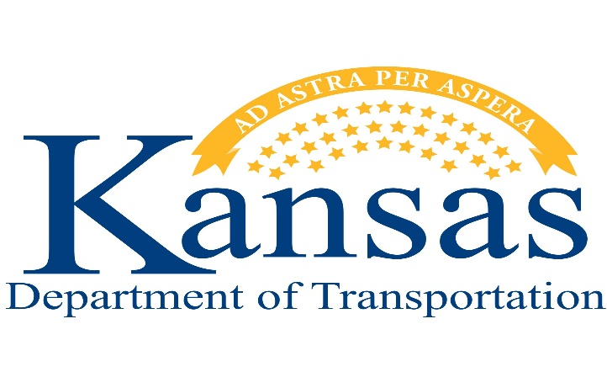

Engineering Internship Program
Application
Website: www.ksdot.org

Name: _______________________________________________________________________

Address: _____________________________________________________________________

City, State, and Zip: ____________________________________________________________

Phone No: ____________________________________________________________________

Email Address: ________________________________________________________________

Anticipated Date of Graduation: __________________________________________________

Positions Available for 2023
Please indicate your 1st, 2nd, and 3rd choice for all positions.

Positions Located in Topeka Headquarters & Statewide Districts (Number of Positions Available)

______ Traffic Engineering (1)
Engineering students in Traffic Engineering will obtain experience in all four Sections of the Bureau (Traffic, Traffic Control, Signing). They will conduct traffic studies under the direction/supervision or assisting an Engineer. They will also analyze crash data and draw collision diagrams when necessary. The students receive experience in permanent signing projects as well as reviewing/designing temporary traffic control plans. The students will attend a wide variety of meetings and field reviews that may require overnight lodging.
______ Road Design - Lawrence (1) Topeka (1)
The interns will work in the design squads to help prepare road projects for highway construction. The work may include some or all the following: operation of a CADD workstation, assisting in developing engineering drawings and notes, checking horizontal and vertical alignments and other geometric elements, preparing spreadsheets, checking/calculating quantities of bid items for construction letting, and general project document management.
______ Bridge Design– Topeka (1) and Lawrence (1)
Bridge Design: The interns will work in a team environment under the supervision of a licensed engineer to help prepare bridge projects for highway construction. The work may include some or all the following: calculating and checking material quantities, detailing bridge plans, checking bridge plans for accuracy (dimensions, etc.), modeling structures in bridge analysis and design software and writing simple software tools using Microsoft applications.
______ Bridge Inspection-Topeka (1)
The intern will work in a team environment under the supervision of a licensed engineer to help inspect bridges for deterioration and other damage. The duties may include researching past bridge repair records, field documentation, assisting in preparing of the inspection reports including structural ratings and data management. Overnight travel should be expected, travel expenses will be reimbursed.

______ Geotechnical Section Topeka (1)
The intern will mentor under the supervision of Engineering Associates and the Chief Geotechnical Engineer learning drilling and sampling techniques, in-situ soil tests, laboratory testing procedures, rudimentary analysis of field and laboratory data, and eventually performing simple projects under the supervision of an engineer. Up to 30 percent overnight travel may be required with travel and per diem paid.
______ Construction & Materials -Regional Material Lab-Shawnee/Kansas City (1)
Engineering or Material interns will assist in sampling, testing, and evaluating materials that will be used in KDOT construction projects. This position will involve travel to Prestressed Beam Fabrication plants, Precast Concrete Plants, Rebar Fabrication & Coating plants, Steel Bridge Fabrication plants and KDOT construction sites.
______ Construction & Materials -Regional Material Lab-Wichita (1)
Engineering or Material interns will assist in sampling, testing, and evaluating materials that will be used in KDOT construction projects. This position will involve travel to Prestressed Beam Fabrication plants, Precast Concrete Plants, Rebar Fabrication & Coating plants, Steel Bridge Fabrication plants and KDOT construction sites.
______ Materials & Research Center - Topeka (1)
Transportation MRC interns will assist in performing laboratory testing for the Physical Test Group. This testing includes testing on aggregates, concrete, cement, and potentially other materials used at KDOT. The testing is performed inside in laboratory conditions and will be working with Engineering Technicians and Engineers within KDOT. The materials testing data is utilized for the prequalification, verification, official qualities, and other approvals of materials that will be utilized in the Kansas State Highway System. Interns may also move around the lab and experience working in other groups with Chemistry and Data Management depending on workload and time.
______ Transportation Planning (1)
The Bureau of Transportation Planning offers engineering interns the opportunity to assist with a wide range of statewide transportation planning activities and Geographic Information Systems (GIS) projects. KDOT staff will develop an internship curriculum tailored to the student’s career goals in planning and general interests (to the extent possible). The work may include the following: field data collection and analysis; GIS database, applications development, and mapping projects; regional travel demand and traffic simulation modeling; sub-area analyses; advanced analytics and economic impact forecasting; corridor and multimodal planning studies. Interns will attend a wide variety of meetings with occasional field work, which may require travel and overnight lodging.
______ Transportation Safety (2) Topeka or Lawrence
The Bureau of Transportation Safety offers planning and engineering interns to work on a wide range of studies and systems-planning efforts aimed at reducing death and serious injury on public roads in Kansas. The interns will have an opportunity to be exposed to data analysis, GIS analysis, behavioral safety concepts, systems planning and engineering, implementation planning, and legislation/policy. KDOT staff will develop an internship curriculum tailored to the student’s career goals in planning and general interests (to the extent possible). The intern may be placed in either the Topeka or Lawrence office.

Field Construction | # of Positions | Job Description
District One
_____ Olathe | 2 | Working on a bridge repair/replacement project or an asphalt paving project in Johnson County. Position will be assisting with processing and performing tests, taking tickets, monitoring contract item quantities, and other inspection work
_____ Bonner Springs | 2 | Assist an engineer/technician with the inspection of materials and construction operations for compliance with plans and specifications
_____ Wamego | 2 | Working on a highway realignment project of K-99 south of Wamego, a pavement marking replacement project on K-18 southwest of Manhattan, and a concrete panel replacement project on I-70 in Riley and Wabaunsee Counties. Position will be assisting with the inspection of contractor’s work in accordance with contract documents and specifications, as well as performing tests, monitoring contract item quantities and other inspection work.
_____ Topeka | 2 | Assist with inspection on a highway modification project on K-31 east of Osage City including grading, bridge construction and asphalt paving on new alignment. Assist with inspection of several asphalt overlay projects in the Topeka area. Assist with inspection of several bridge repair projects in the Topeka area. Position will be assisting with processing and performing tests, taking tickets, monitoring contract item quantities & spread rates and other inspection work on these projects.
_____ Emporia | 1 | Assist with inspection on a highway modification project on K-31 east of Osage City including grading, bridges, and asphalt paving on new alignment. Assist with inspection on a highway modification project on US-50 west of Emporia including grading, bridge modification and concrete paving. Position will be assisting with processing and performing tests, taking tickets, monitoring contract item quantities & spread rates and other inspection work on these projects.
_____ Horton | 1 | Assist an engineer/technician with the inspection and testing of materials and construction operations for compliance with plans and specifications on US-75 highway passing lane projects in Brown and Jackson County. The project scope includes grading, surfacing, seeding, signing and pavement marking. Construction work will include asphalt milling, overlay and new paving, road embarkment grading and compaction, and removing/replacing existing concrete structures.
District Two
_____ Salina | 1 | Assist an engineer/technician with the inspection of materials and construction operations to ensure compliance with plans an specification. This will require some understanding of the plans and specifications.
_____ Belleville | 1
_____ Junction City | 1
_____ Marion | 1
District Three
_____ Hays | 1 | Assist an engineer/technician with the inspection of materials and construction operations to ensure compliance with plans and specifications. This will require some understanding of the plans and specifications.
_____ Phillipsburg | 1
_____ Oakley | 1
_____ Atwood | 1
District Four
_____ Pittsburg | 1 | Job duties will be general construction inspection and materials testing on road and bridge projects. Other duties such as performing calculations, design, drafting, reporting, etc., may be assigned depending upon the person’s experience and capabilities
_____ Garnett | 1
District Five
_____ Wichita | 2 | Will assist with the inspection of bridge repairs, new bridge construction, concrete paving, asphalt overlay, major interchange reconstruction North I-135/I-235 junction, surveying, and or development of contract repairs. Nightwork maybe required on some projects
_____ Winfield | 1 | Asphalt Overlay construction projects, bridge repair and replacement projects, plus other duties such as performing calculations, design, drafting, reporting, etc., may be assigned depending upon the person’s experience and capabilities.
_____ Hutchinson | 1 | A major highway expansion project that will involve bridge, earthwork, structure, asphalt, traffic control, stormwater inspection, as well as other construction inspection related items such as surveying and material testing.
_____ Great Bend | 1 | Asphalt Overlay construction projects and Major highway expansion project that will involve bridge, earthwork, structure, asphalt, traffic control, stormwater inspection, as well as other construction inspection related items such as surveying and material testing.
_____ Pratt | 1 | Bridge construction. Hot mix asphalt construction. Earthwork construction and base treatment. Concrete pavement construction. Concrete pavement patching. Pavement marking.
District Six
_____ Garden City | 1 | Job duties will be general construction inspection and materials testing on road and bridge projects. Other duties such as performing calculations, design, drafting, reporting, etc., may be assigned depending upon the person’s experience and capabilities
_____ Syracuse | 1
_____ Ulysses | 1
_____ Dodge City | 1

Do you have relatives working at KDOT?
If so, whom_________________________________
location ________________________________________

All applicants must be at least 18 years of age by their first date of employment.
Are you at least 18 years old or will be 18 years old by your first date of employment? _____Yes _____No

I affirm that the facts set forth above in my application for the Engineering Internship Program are true, correct, and complete to the best of my knowledge. I understand that I may be required to submit information not requested on this application form, that the employing agency may verify any information provided by me in the application and selection process, and that incomplete information or omission of my signature is just cause for rejection of my application.

In the event I am selected, I also understand that any omission of information or erroneous information provided in any part of the application and selection process would be cause for discharge.

_______________________________________ ______________________________
Signature of Applicant Date

Please make certain that you return the following:

1. Application
2. Certification of Enrollment in an Engineering Program
3. Resume
4. Transcript (can be an unofficial copy)

Scan and return to the following email address:

Luci Zieman
Recruiter
Kansas Department of Transportation
kdot.hq.jobapps@ks.gov

If you have questions, please contact Luci Zieman - 785-296-6749

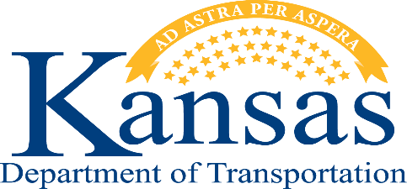

Certification of Enrollment in an ABET Accredited
Engineering Program

This notice will serve as certification that ___________________________is currently enrolled in the (Name of Student)

Engineering Program at____________________________________________________________________ .
(Name of School)

In the Fall 2023 semester, this student will be entering their:

_____Sophomore Year _____Junior Year _____Senior Year

________________________________________________________________________
(Student Signature) (Date)

________________________________________________________________________
(Engineering Dept. Chairman’s Signature) (Date)

This form must be completed and returned with the Kansas Department of Transportation Employment Application.

