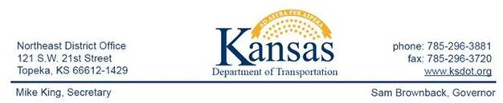

FOR IMMEDIATE RELEASE
June 23, 2015
News Contact: Kimberly Qualls, (785) 640-9340 or kqualls@ksdot.org
Jerry Haug, (785) 456-2353 or jerryh@ksdot.org
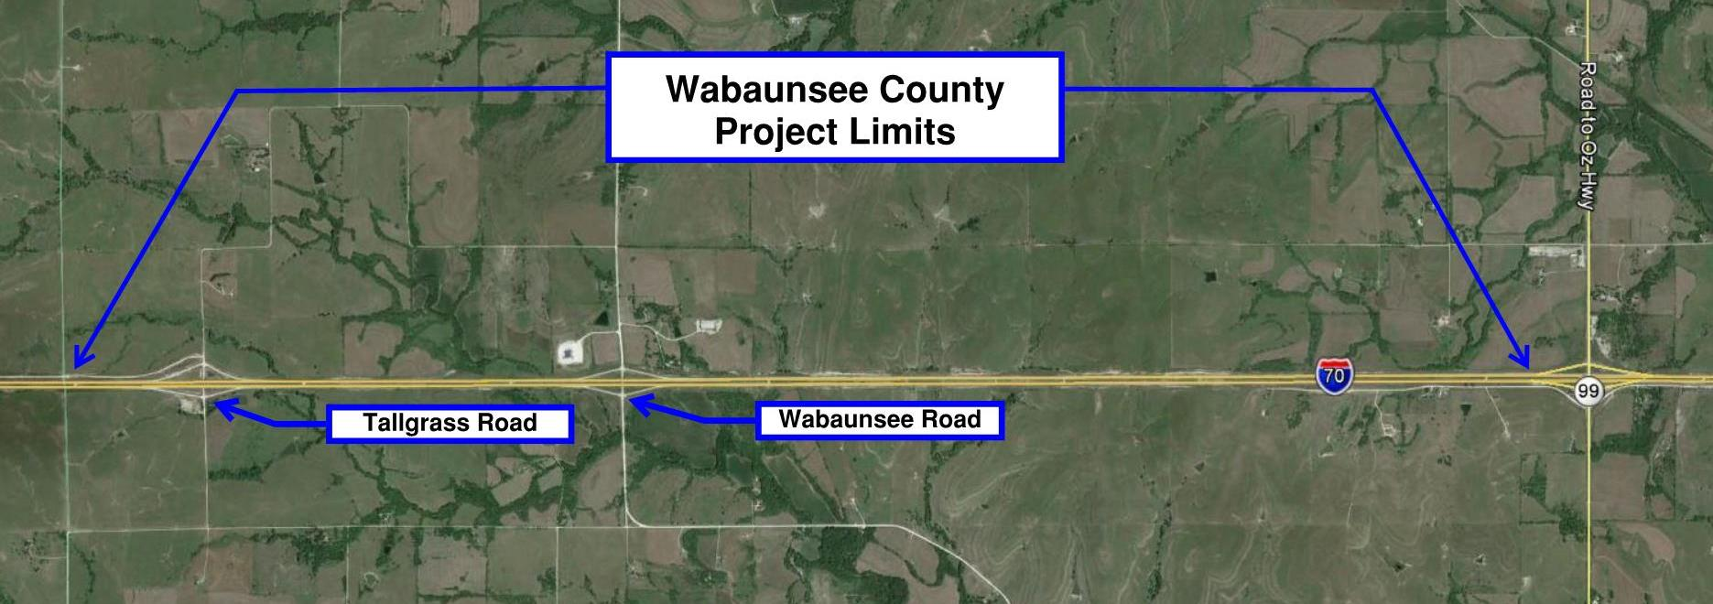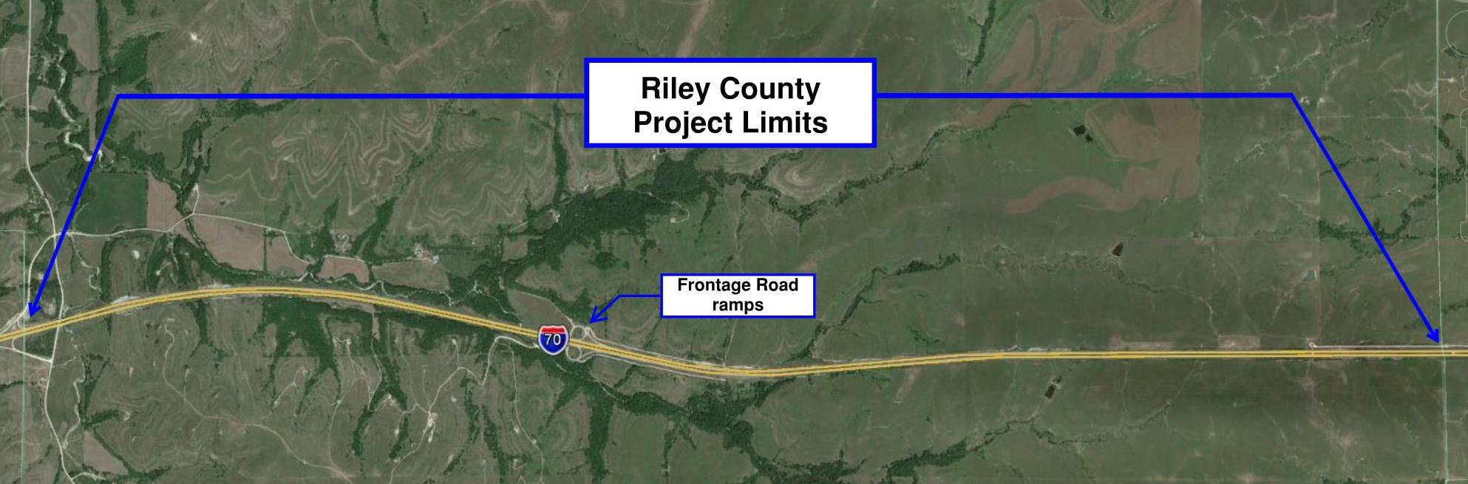
I-70 Pavement Marking Project to Begin
in Riley & Wabaunsee Counties
On Monday, June 29, a pavement marking project will begin on a 12.19-mile stretch of I-70 from the Geary/Riley County line east to the K-99 junction in Wabaunsee County. In addition, pavement marking work will take place on the interchange ramps at Frontage Road (Riley County), Tallgrass Road and Wabaunsee Road, and on the westbound I-70 bridge over Mill Creek (Wabaunsee County). Project work will take place during daylight hours, Monday through Saturday (excluding holiday weekends).
Beginning on Monday, June 29, weather permitting, eastbound and westbound I-70 will be reduced to ONE OPEN LANE in one direction at a time in several mile increments as crews begin pavement marking operations. Crews will first complete work on the Riley County portion of I-70, beginning in the westbound lanes, then will move to the Wabaunsee County portion to complete the remainder of the project work. All interchange ramps will remain open throughout the project duration. Traffic will be directed through the project work zone via cones and signage.
The Kansas Department of Transportation urges all motorists to be alert, obey the warning signs, and “Give ‘Em a Brake!” when approaching and driving through the project work zone.
Twin Traffic Marking Corporation (Kansas City, KS) is the primary contractor on this pavement marking project with a total contract cost of $520,545. Project work is scheduled to be completed in late September 2015, weather permitting.
This project is funded by T-WORKS, the transportation program passed by the Kansas Legislature in May 2010. Find out more about this and other T-WORKS projects at: http://kdotapp.ksdot.org/TWorks/.
For more information on this project, please contact Kimberly Qualls, Northeast Kansas Public Affairs Manager, at (785) 640-9340, or Jerry Haug, Wamego Construction Engineer, at (785) 456-2353. (KDOT Project #70-81 KA-4146-01 & 70-99 KA-4147-01)
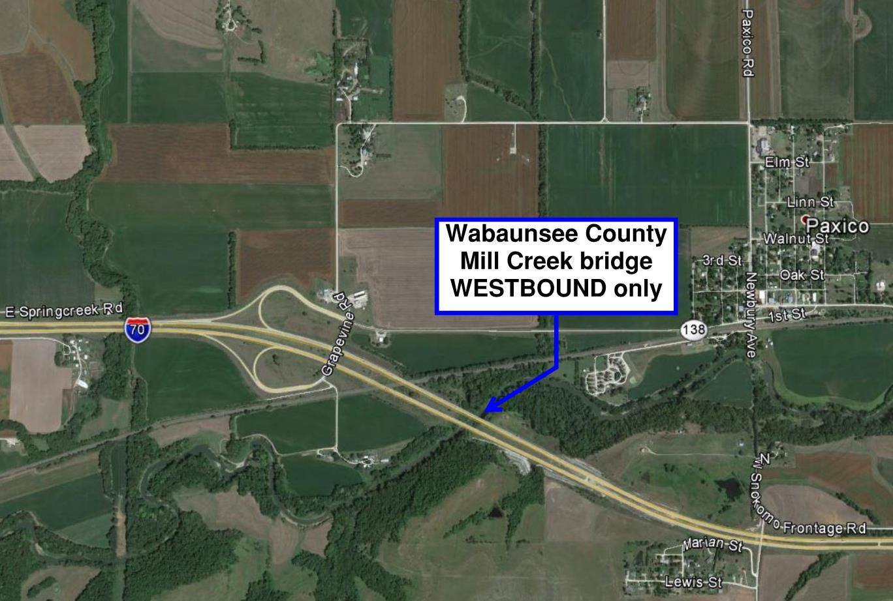
###

This information is available in alternative accessible formats. To obtain an alternative format,
contact KDOT Office of Public Affairs, Eisenhower Building, 700 SW Harrison,
2nd Floor West, Topeka, Kan., 66603-3754, or (785) 296-3585 (Voice)/Hearing Impaired - 711.

Click below to connect to NE Kansas KDOT’s Social Networks:


