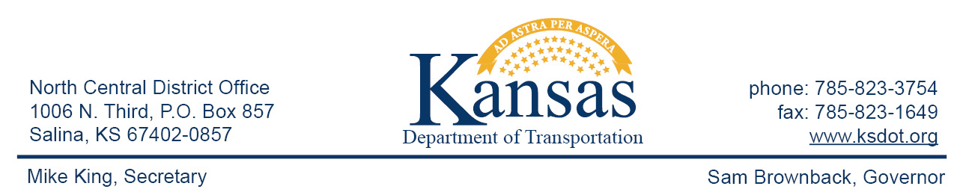

FOR IMMEDIATE RELEASE

March 23, 2016

News contact: David Greiser, (785) 823-3754
dgreiser@ksdot.org

US-36 Highway Reconstruction in Jewell County

Beginning, Monday, March 28, 2016, US-36 traffic within the city of Mankato will be restricted to one 11’ wide lane in each direction for the full depth reconstruction of the highway. This project extends the length of the city limits beginning 4.4 miles east of the east US-36/K-128 junction then east to a point 1.6 miles west of the west US-36/K-14 junction.

Plans call for US-36 to be reconstructed as a 4-lane highway. Included in the project are new storm sewers. New curb and gutter will be installed from High St. to the west city limit.

Plans call for the project to be completed in mid-January, 2017 weather permitting.

The purpose of the project is to extend the life of and improve ride quality and functionality of the Highway.

Venture Corp. of Great Bend, KS, is the prime contractor. Project cost is $4,602,610.25.

####

This information can be made available in alternative accessible formats upon request.
For information about obtaining an alternative format, contact the Bureau of Transportation Information,
700 SW Harrison St., 2nd Fl West, Topeka, KS 66603-3754 or phone 785-296-3585 (Voice)/Hearing Impaired – 711.

Click below to connect to Social Networks:

