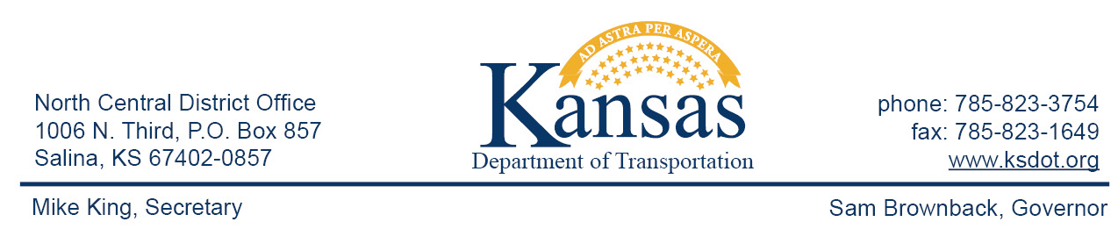

FOR IMMEDIATE RELEASE

June 26, 2015

News contact: David Greiser, (785) 823-3754
dgreiser@ksdot.org

US-77 Improvements at Junction City to Begin (UPDATE)

The first phase involves the closing of Lacy Dr. just west of the Sapp Brothers Travel Center entrance has been delayed. Construction should begin Monday, July 6, 2015 and is scheduled to be completed by mid-July weather permitting.
While this section of Lacy Dr. is under reconstruction access to the travel center and Armour Eckrich Meats plant will remain open from the east. Those wanting to access these business or US-77 from the west will need to take Spring Valley Rd. north to Ash St. then east to either Sandusky Dr. or US-77 then south to Lacey Dr.
A planned list of improvements on US-77 as it passes through the Junction City area are about to begin construction. The first project in addition to the divergent Diamond Interchange at US-77/I-70 will include improvements to the Rucker Rd/US-77 Intersection, Spring Valley Rd between Rucker Rd and Sutter Woods Rd, a portion of Lacy Dr. and a continuation of the southbound US-77 climbing lane south of the K-57/K-24/US-77 intersection. The construction will be completed in several phases over the course of 3 years.

Hamm Inc. of Perry, KS is the prime contractor. Project cost is $10,094,133.63.

####

This information can be made available in alternative accessible formats upon request.
For information about obtaining an alternative format, contact the Bureau of Transportation Information,
700 SW Harrison St., 2nd Fl West, Topeka, KS 66603-3754 or phone 785-296-3585 (Voice)/Hearing Impaired – 711.

Click below to connect to Social Networks:

