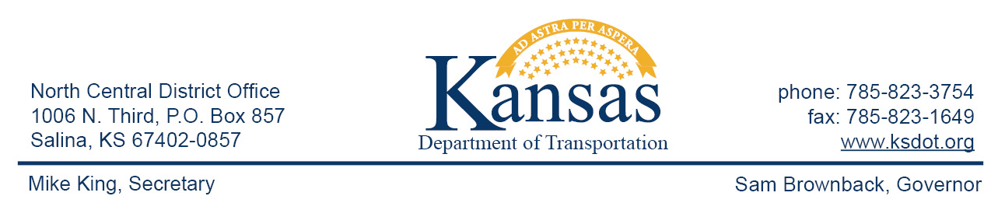

FOR IMMEDIATE RELEASE

July 10, 2015

News contact: David Greiser, (785) 823-3754;
dgreiser@ksdot.org

K-43 overlay in Dickinson County

As of Friday, July 17th a portion of K-43 in Dickinson County will receive a 3” asphalt overlay. The project begins at the western K-43/1400 Rd. junction then north to the I-70/K-43/Mink Rd. Interchange. The city of Enterprise will be excluded from this project. Traffic will be carried through construction via flagger and pilot car during daylight hours. There will be a 12’ width restriction within the work zone. Plans call for the project to be completed on or about August 31st weather permitting.
The purpose of this project is to extend the life of the roadway and improve the ride quality.

This project is funded through T-WORKS. For more information concerning the T-works program and specific projects visit the T-works web site at www.ksdot.org/tworks.

####

This information can be made available in alternative accessible formats upon request.
For information about obtaining an alternative format, contact the Bureau of Transportation Information,
700 SW Harrison St., 2nd Fl West, Topeka, KS 66603-3754 or phone 785-296-3585 (Voice)/Hearing Impaired – 711.

Click below to connect to Social Networks:

