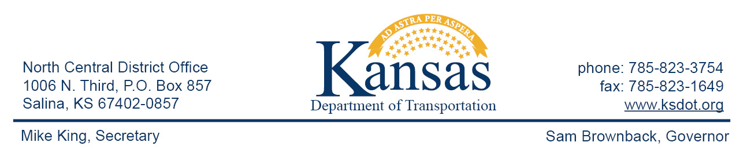

FOR IMMEDIATE RELEASE

July 16, 2015

News contact: David Greiser, (785) 823-3754;
dgreiser@ksdot.org

K-28 Bridge Replacement (Correction 3)

Please disregard the news release for the construction of a new bridge replacing the bridge located on K-28 at the Jewell/Cloud County line. The release was sent in error.
The correct release is as follows:

As of Monday, July 20, 2015, K-28 will be closed to allow for the construction of a new bridge replacing the bridge located on K-28 5.7 miles east of K-14 in Jewell County. All traffic will be carried through construction on a shoofly detour. The detour will be a rock surface with 14’ Wide lanes.
Plans call for the construction of the new bridge on or about Dec. 18th weather permitting.
This project is funded through T-WORKS. For more information concerning the T-works program and specific projects visit the T-works web site at www.ksdot.org/tworks.

####

This information can be made available in alternative accessible formats upon request.
For information about obtaining an alternative format, contact the Bureau of Transportation Information,
700 SW Harrison St., 2nd Fl West, Topeka, KS 66603-3754 or phone 785-296-3585 (Voice)/Hearing Impaired – 711.

Click below to connect to Social Networks:

