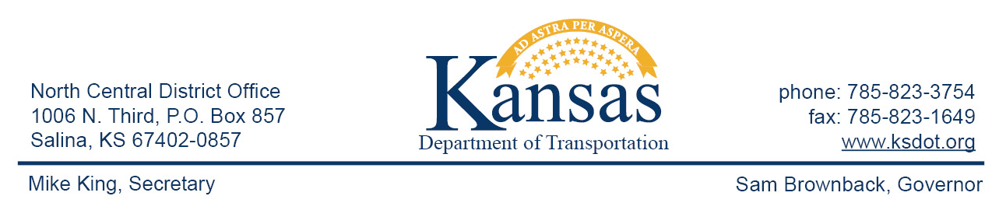

FOR IMMEDIATE RELEASE

July 15, 2015

News contact: David Greiser, (785) 823-3754;
dgreiser@ksdot.org

K-28 Bridge Replacement (Correction 2)

As of Monday, July 21, 2015, K-28 will be closed to allow for the construction of a new bridge replacing the bridge located on K-28 at the Jewell/Cloud County line. Eastbound traffic will be detoured beginning at the K-28/K-148 junction then east on K-148 to US-81 then south to K-9 then west to rejoin K-28 just west of Concordia. Westbound traffic will follow the same detour in reverse.

Plans call for the construction of the new bridge on or about Dec. 19th weather permitting.

This project is funded through T-WORKS. For more information concerning the T-works program and specific projects visit the T-works web site at www.ksdot.org/tworks.

####

This information can be made available in alternative accessible formats upon request.
For information about obtaining an alternative format, contact the Bureau of Transportation Information,
700 SW Harrison St., 2nd Fl West, Topeka, KS 66603-3754 or phone 785-296-3585 (Voice)/Hearing Impaired – 711.

Click below to connect to Social Networks:

