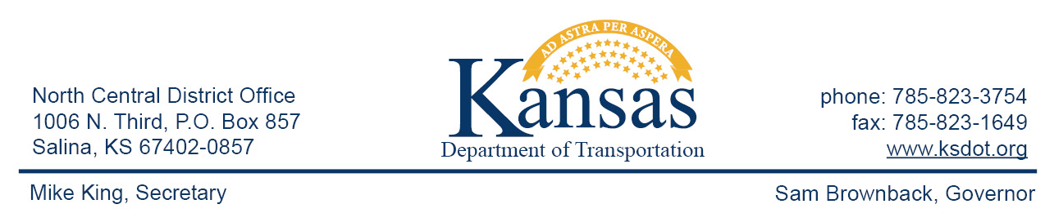

FOR IMMEDIATE RELEASE

June 23, 2015

News Contact: David Greiser (785) 823-3754

I-70 Bridge Deck Repair to take place in Geary County

The Kansas Department of Transportation began emergency road repairs on an eastbound bridge on I-70 in Geary County on the eastbound lanes at the Madison St. Overpass (mm296), Monday, June 22rd.

Traffic will be reduced to one lane for the duration of the project. Drivers are also able to access the shoulder with-in the work zone. Plans call for repairs on the driving lane to require one week.

Plans call for the project to be completed in late June 29th, weather permitting.

This information can be made available in alternative accessible formats upon request.
For information about obtaining an alternative format, contact the Bureau of Transportation Information,
700 SW Harrison St., 2nd Fl West, Topeka, KS 66603-3754 or phone 785-296-3585 (Voice)/Hearing Impaired – 711.
###

Click below to connect to Social Networks:

