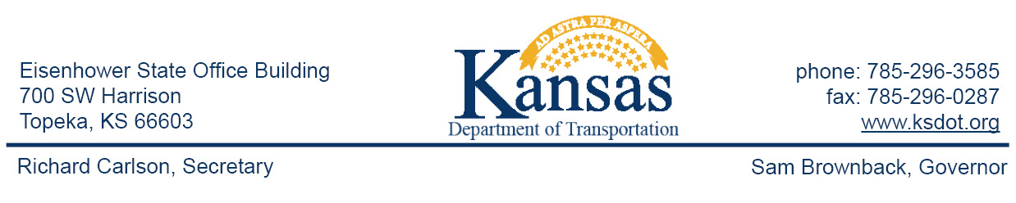

**IMMEDIATE RELEASE**June 5, 2017

**For more information:**Lisa Knoll

620-765-7080

lisa.knoll@ks.gov

Guard Rail and Post Repairs Postponed in Clark County

Guard rail and posts repairs on K-34 and U.S. 160 in Clark County have been postponed until June 26th due to a reported materials delay from the contractor. New posts and guard rail end terminals and sections at various locations along these routes are being replaced. Drivers should remain alert for advanced signing and be prepared to slow and/or stop on short notice as workers, materials and equipment will be very near the traffic. Work is scheduled to begin the week of June 26, 2017 and continue through the mid-August, weather permitting.

For more information on this project, please contact Joyce Muhlenbruch, Construction Engineer, at (620)227-6122 or Lisa Knoll, KDOT District 6 Public Affairs Manager, at 620-765-7080. Updated information will also be available on Facebook at Kansas Department of Transportation – Southwest Kansas and on Twitter @SWKansasKDOT.

You can stay aware of all road construction projects across Kansas at [www.kandrive.org](http://www.kandrive.org) or by calling 5-1-1.

###

This information can be made available in alternative accessible formats upon request.

For information about obtaining an alternative format, contact the KDOT Office of Public Affairs,

700 SW Harrison St., 2nd Fl West, Topeka, KS 66603-3754 or phone 785-296-3585 (Voice)/Hearing Impaired – 711.

|  |
| --- |
| Click below to connect to KDOT’s Social Networks:  [Description: Facebook-Logo.png](https://www.facebook.com/KSDOTHQ/)    [Description: twitter.png](https://twitter.com/KDOTHQ)    [Description: youtube_logo.jpg](https://www.youtube.com/user/kansastransportation)    [Description: Flickr-logo.jpg](http://www.flickr.com/photos/kansastransportation)    [cid:image010.png@01D2037D.38368C60](http://kansastransportation.blogspot.com/) |