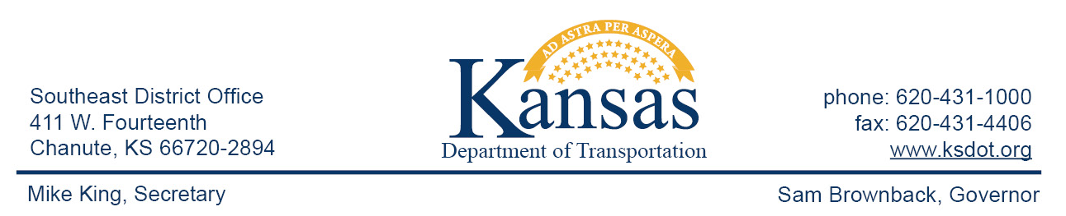

FOR IMMEDIATE RELEASE
June 22, 2016
News contact: Priscilla Petersen, (620) 431-1000; Priscilla@ksdot.org

KDOT placing asphalt on U.S. 169 side roads and entrances

Maintenance crews with the Kansas Department of Transportation (KDOT) have started a project to place asphalt at most of the entrances and side roads along U.S. 169 in Montgomery County. The work began at the Labette-Montgomery county line and is continuing south for approximately 17 miles to end at the four-lane section. Project activity will occur weekdays between the hours of 8:00 a.m. and 2:30 p.m., weather permitting.
U.S. 169 mainline traffic should not be significantly affected by the repairs. KDOT will work to ensure minimal delays for traffic moving through the work zones on county roads and private entrances.
Persons with questions may contact Independence KDOT Superintendent Marcus Leck at (620) 331-3760.
#########
This information can be made available in alternative accessible formats upon request.
For information about obtaining an alternative format, contact KDOT Public Affairs,
700 SW Harrison St., 2nd Fl West, Topeka, KS 66603-3754 or phone 785-296-3585 (Voice)/Hearing Impaired – 711.

Click below to connect to KDOT’s Social Networks:

