KDOT PUBLIC TRANSPORTATION
VEHICLE DAMAGE REPORT FORM

Vehicle VIN:____________________________ Odometer:___________ Driver Name:___________________

Date: _________ Agency: ___________________________ Point of Contact: _________________________

Any damage to the vehicle should be noted on the illustrations below. Circle the area that has damage and note what the damage is and how the damage occurred.
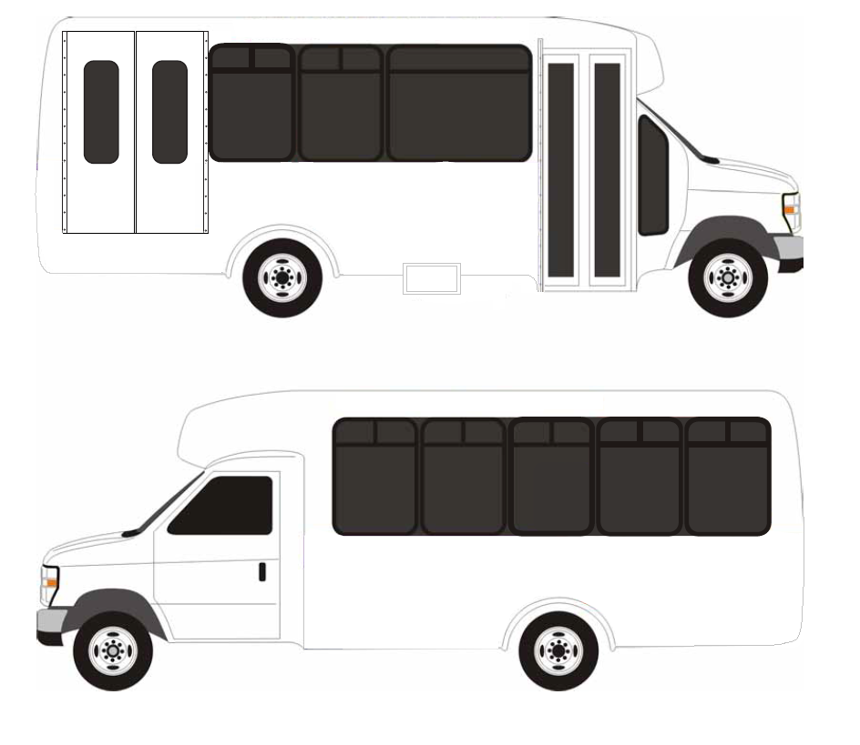

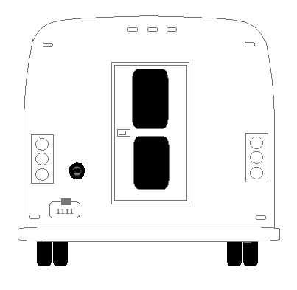

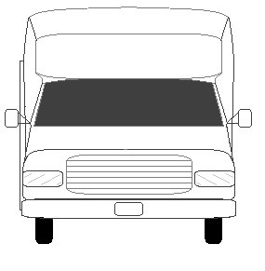

Explanation of Damage: _____________________________________________________________________
____________________________________________________________________________________________________________________________________________________________________________________
____________________________________________________________________________________________________________________________________________________________________________________
Use additional pages as necessary.

Explanation of Incident: _____________________________________________________________________
____________________________________________________________________________________________________________________________________________________________________________________
________________________________________________________________________________________________________________________________________________________________________________________________________________________________________________________________________________________________________________________________________________________________________
Use additional pages as necessary.

Was a police report filed?: Yes No If so, police reporting number: ______________________

Has the FTA post-accident form been completed?: Yes No

Was anyone injured?: Yes No If so, who?: ____________________________________

Were there any passengers on board at the time of accident?: Yes No If so, how many?: ________

Was a drug screening performed?: Yes No
If so, please email results to KDOTtransit@ks.gov

Was the Vehicle Totaled: Yes No

Cost of Repair / Totaled Amount: __________________

NTD Reportable Incidents:
A safety or security event occurring on transit right-of-way or infrastructure, at a transit revenue facility, at a transit maintenance facility or rail yard, during a transit related maintenance activity or involving a transit revenue vehicle that results in one or more of the following conditions (please check any that apply):
A fatality confirmed within 30 days of the event
An injury requiring immediate medical attention away from the scene for one or more person
Property damage equal to or exceeding $25,000
Collisions involving transit revenue vehicles that require towing away from the scene for a transit roadway vehicle or other non-transit roadway vehicle
An evacuation for life safety reasons

Signature:______________________________ Date:______________

